Origin and Evolution of the Genus Homo

# Defining the Genus Homo

* Relative to Au. , *Homo* has:
  + Larger braincase

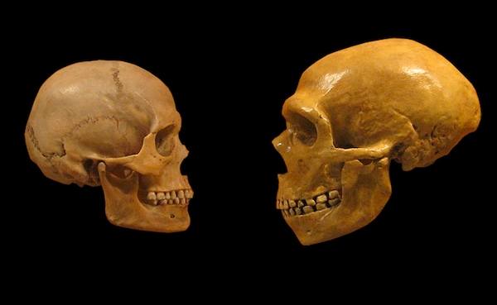 (Human on the left and Neanderthal on the right)

* + Smaller and less prognathic face
    - Flatter face

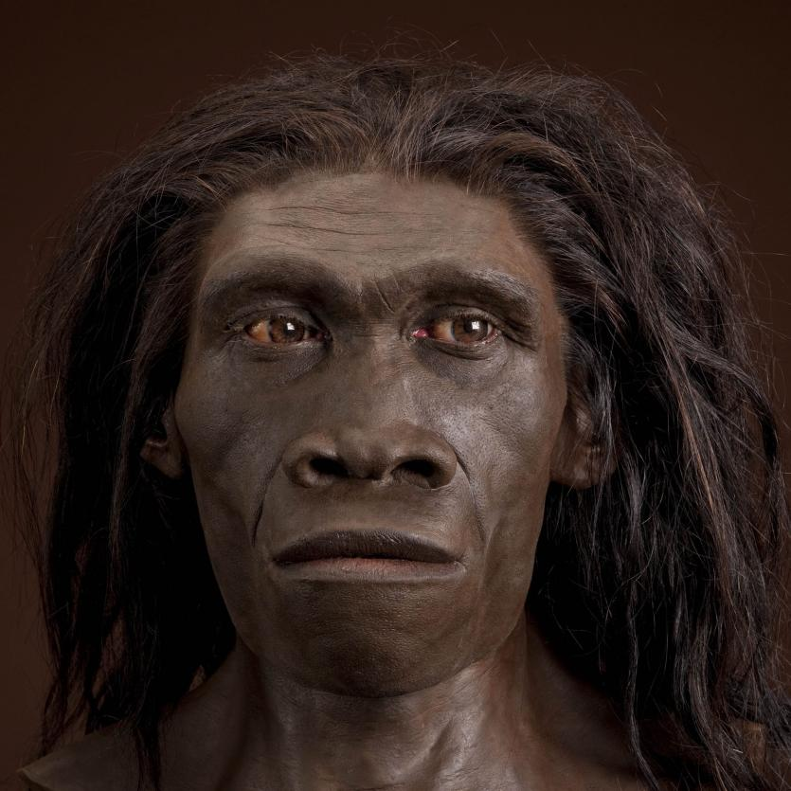

* + Larger body
    - Becoming challenged with new information that is coming out
    - There are more humans discovered that are smaller in stature
  + More efficient striding bipedalism
  + More animal based diet
    - Better nutrition delivery system than eating more plants
  + More tool use to process and extract food such as stones
* Some say *Homo* is too inclusive, brain volume ranges over 3x difference with Au, with teeth and face proportions changing greatly (compared to range seen over other hominid genera)

**Homo Habilis**

* Sometimes two species: possibly male and female
  + Smaller *habilis*
  + Larger *rudolfensis*
* 2.5 to 1.6 MYA
* Elevated forehead due to expanded brain (~800 CC), more human-like appearance
* Human-like thumb and hands
* The “first tool maker”
  + Oldowan stone tools (oldest tool set we will be covering)

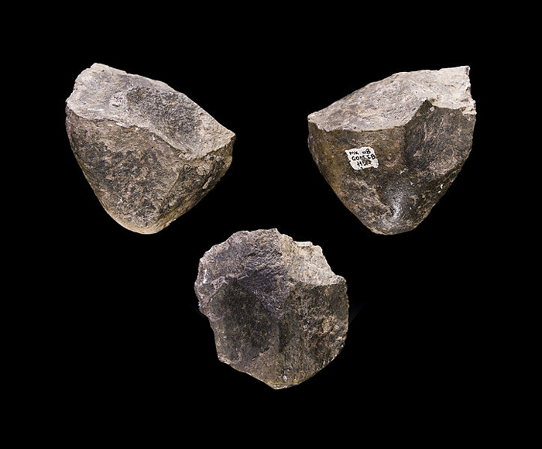

* + Evidence of butchering
  + We now know that Au and chimps also used tools as well

**Homo Ergaster**

* 1.8 to 1.1 MYA
* Oldest *erectus* at 1.9 to 1.8 MYA
* Turkana boy (about 8 years old)
* Thinner cranium, less brow ridge than *erectus*, very human-like in many respects
* Maybe good at persistence hunting
* May have been first hominid to leave Africa and ancestor to Neanderthal